# DriverPass System Design Document

## UML Diagrams

### UML Use Case Diagram

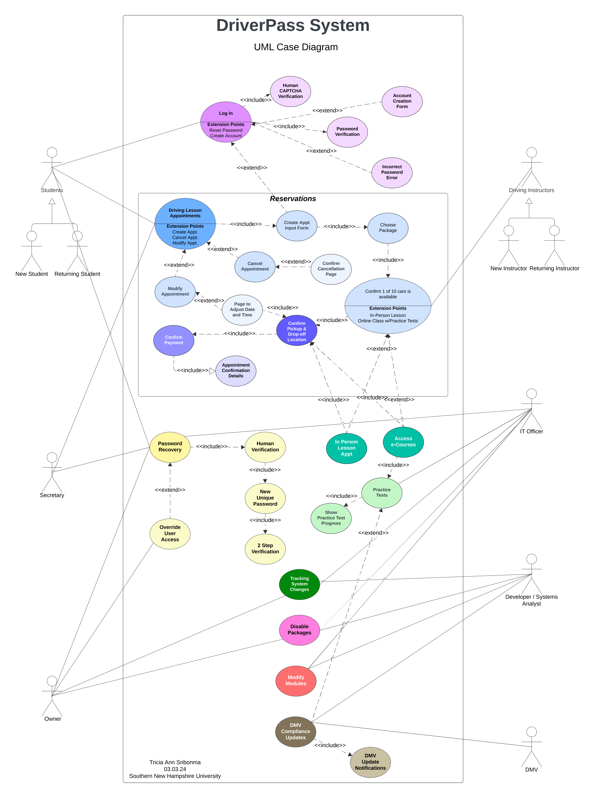

### UML Activity Diagrams

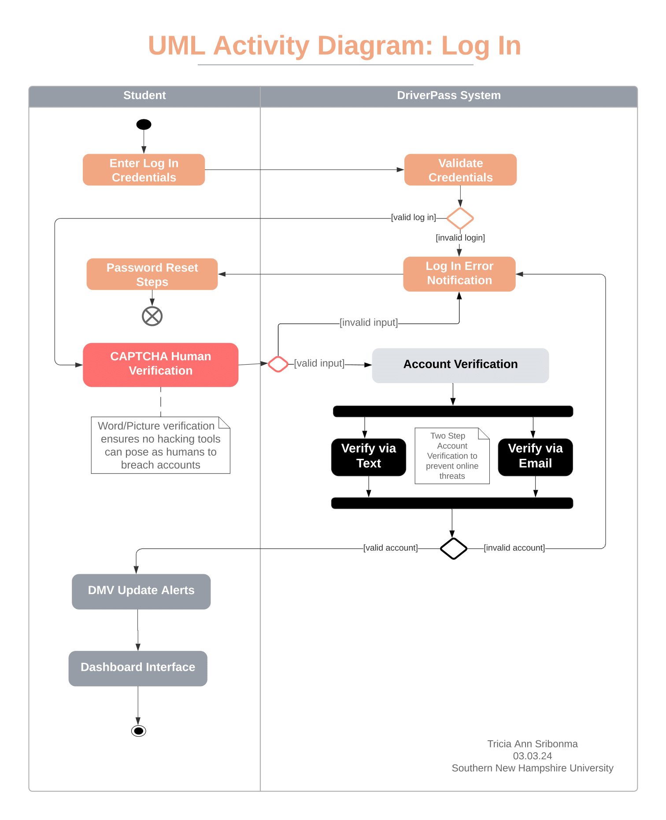

### UML Sequence Diagram

### UML Class Diagram

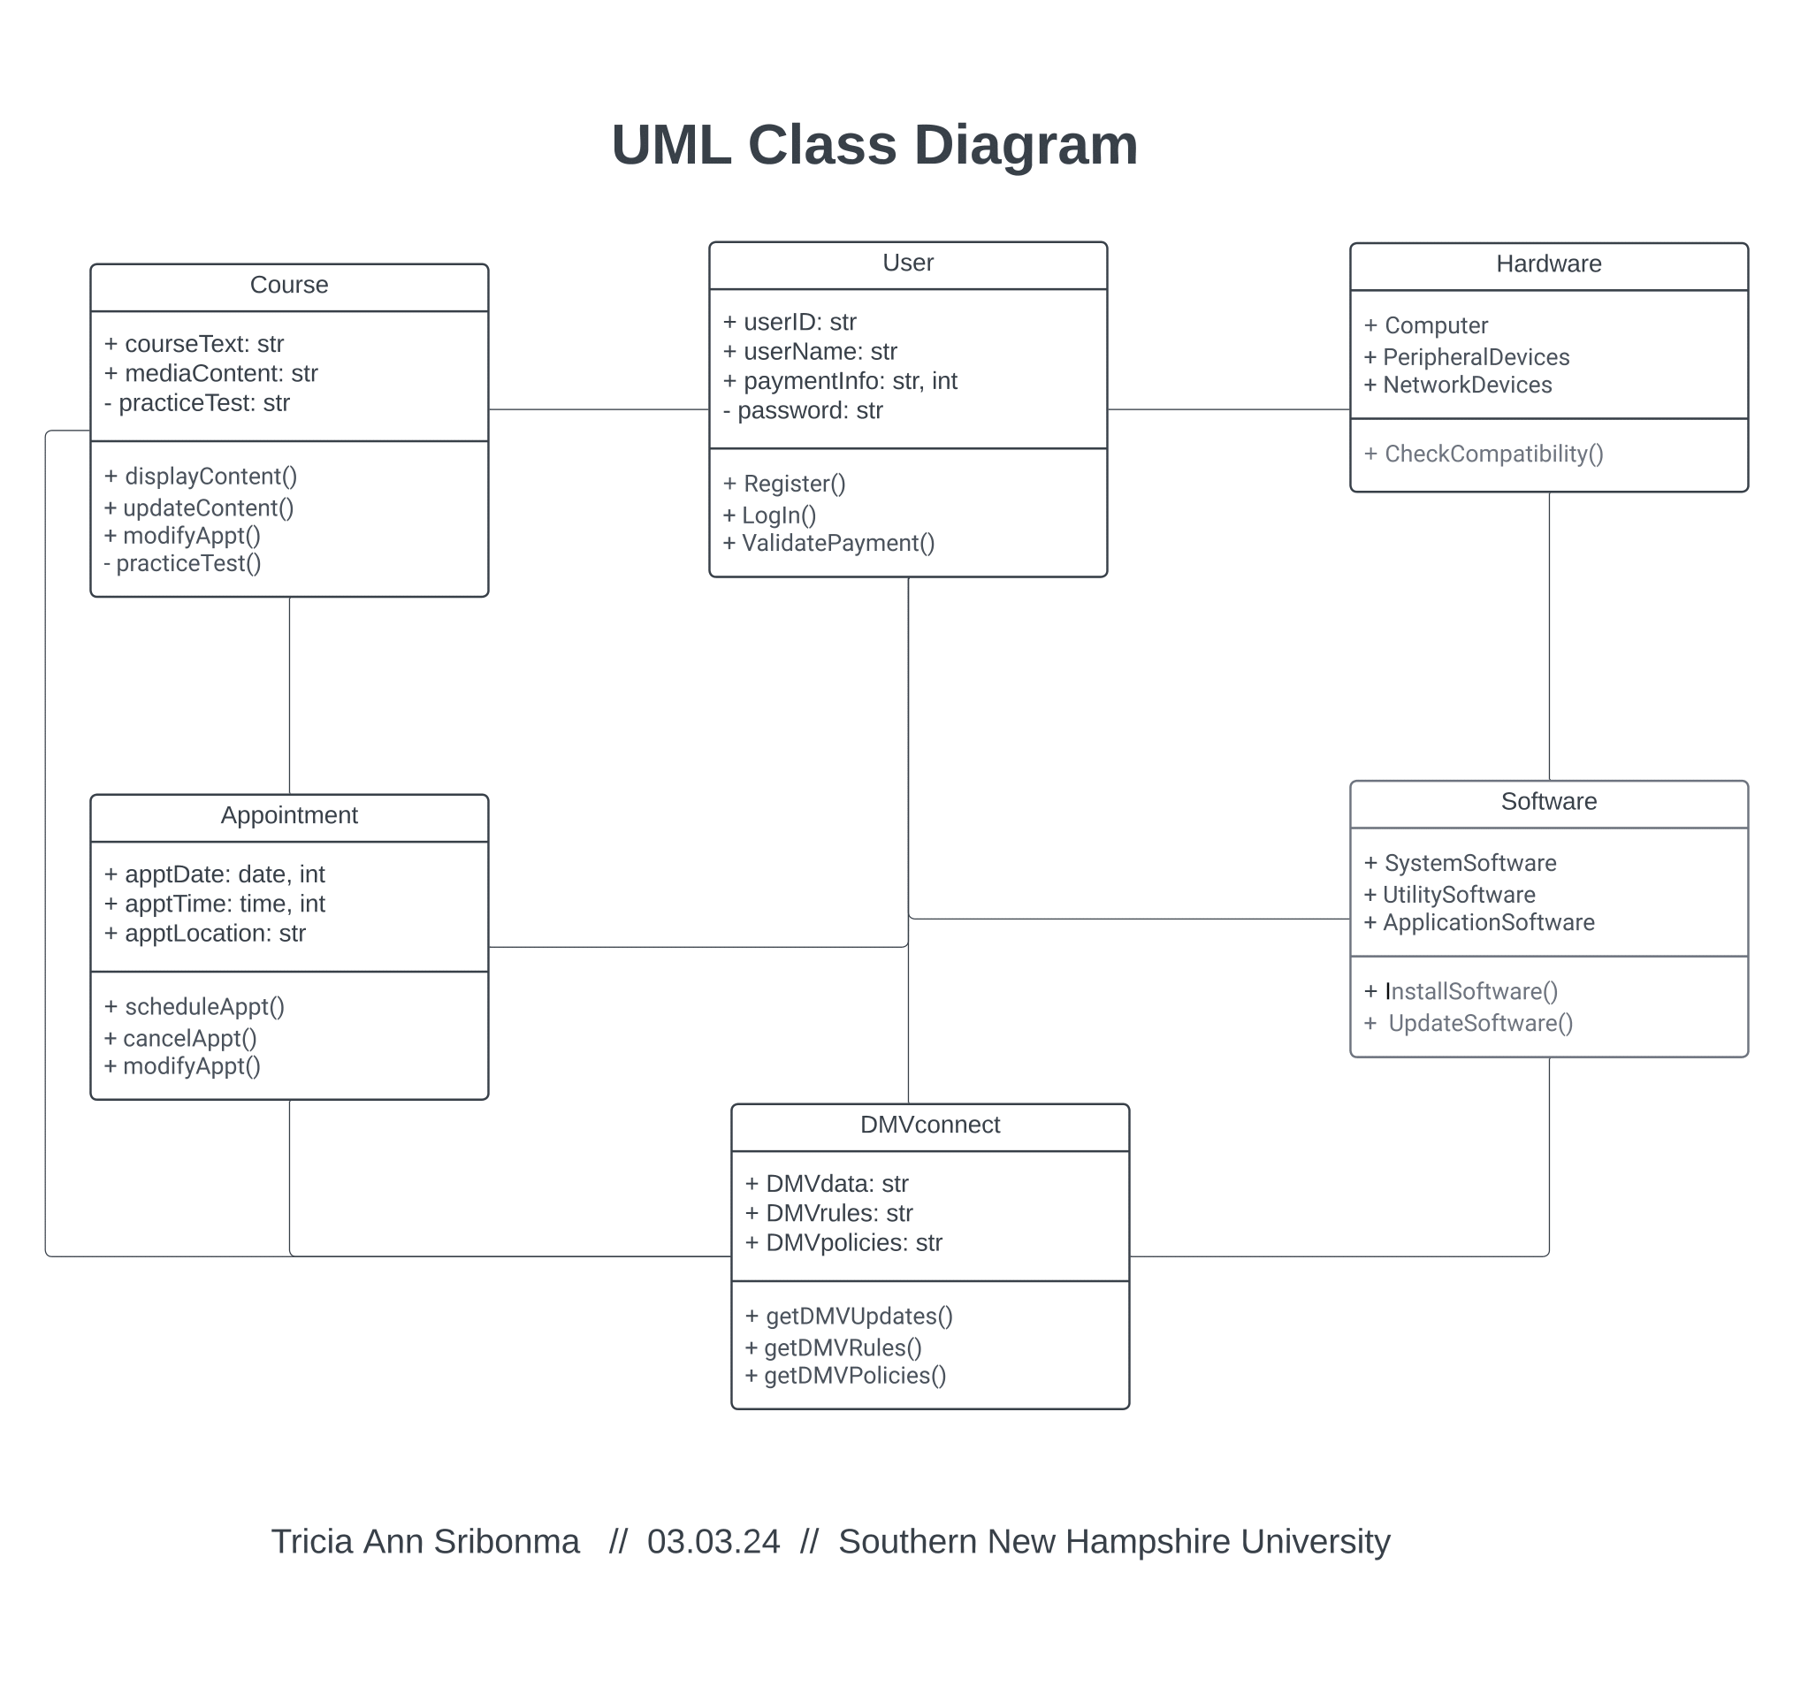

## Technical Requirements

When establishing technical requirements, it's imperative to align hardware and software needs with client expectations and user demands. Considering the potential user base and their technological preferences ensures the system's inclusivity and accessibility. Technical requirements play a pivotal role in shaping system design and directly influence nonfunctional aspects. Recommendations for specific hardware and software components ensure the system's reliability, security, and optimal performance. This includes:

* **Frequency of Software Updates:** Planning for updates during low-traffic periods to minimize service interruptions. Utilizing automated update mechanisms to streamline the process.
* **Support:** Establishing a comprehensive support system, including clear user guides and a dedicated helpline for immediate assistance in case of issues.
* **Languages:** Offering a language selection feature within the application interface to cater to a diverse user base.
* **Accuracy:** Employing precision-engineered hardware components and regularly updating software algorithms to ensure accurate simulation and training results.
* **Security:** Implementing encryption protocols for data safety, multi-factor authentication for user access, and regular security audits to identify and address vulnerabilities promptly.

**Hardware:**

* + **Computers:** Compatibility with a range of computers, including both desktops and laptops, to accommodate various user preferences. Recommending systems with at least 8GB RAM and modern processors for optimal performance.
  + **Peripherals:** Support for common peripherals like printers for generating certificates or documents, scanners for document verification, and cameras for video-based training sessions.
  + **Networking:** Robust networking capabilities, suggesting the use of reliable routers and network adapters to ensure seamless communication between users and the DriverPass system.
  + **Graphic Cards:** Integration of graphic cards to enhance the visual quality of training materials and simulations, providing a more engaging learning experience.
  + **Routers:** Recommendations for reputable routers with dual-band functionality to handle the bandwidth demands of video content and interactive lessons.

**Software:**

* + **System Software:** Compatibility with major operating systems (Windows, MacOS, and Linux) to reach a wider user base. Ensuring the system operates efficiently on the latest versions of these operating systems.
  + **Utility Software:** Incorporation of utility software for data encryption, regular backups, and system diagnostics to maintain the integrity and security of user data. Recommending industry-standard tools like BitLocker for encryption and Acronis for backups.
  + **Application Software:** Developing the DriverPass application to be cross-platform compatible, supporting popular browsers such as Google Chrome, Mozilla Firefox, and Safari. Utilizing responsive design principles for a consistent user experience across devices.

**Geographic Information and Other:**

* + **Location of the System:** Adapting the system to different geographical locations by considering factors like time zones, regional driving regulations, and internet connectivity variations.
  + **Surrounding (Physical) Environment:** Acknowledging the potential impact of physical surroundings on hardware performance. Recommending durable hardware components and, if applicable, climate-controlled storage for server infrastructure.

In summary, meticulous consideration of hardware and software specifics ensures the DriverPass system not only meets technical standards but exceeds user expectations, providing a secure, adaptable, and efficient learning platform for aspiring drivers.